Generating Radial Lines
In ArcGIS I created radial lines from the ignition points to the fire perimeter using the "Bearing Distance to Line" tools. This generated 360 geodetic lines to the fire perimeter. The input for generating the lines was a csv made below. Preserve the attributes so that the Event_ID is retained.I then generated points along the lines, and did a spatial join with the fires layer using an attribute filter with Event_ID. This gives me points within the fire perimeter spaced every 50m (planar) from the ignition point. Export the results of the spatial join as AllPoints. You will have to take out the TargetFID and Date fields for export.

Use the Radial Lines input created in R and the Bearing to Distance tool in ArcGIS
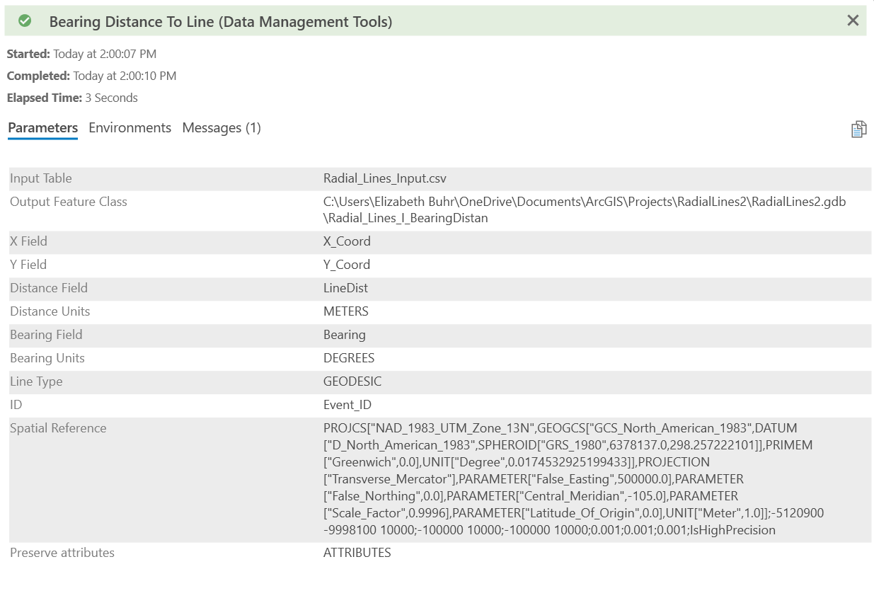
Generate points along transect lines
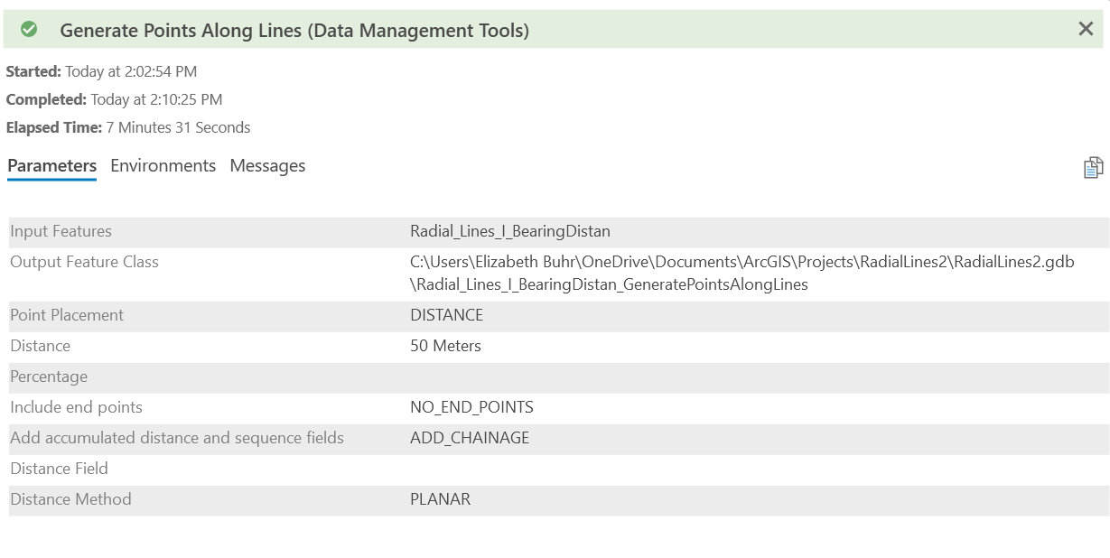

Do a spatial join between the points and fire
